
Colonial Corvair Club and The Bug Club present

VolksVair X

Tenth Annual Corvair and Volkswagen Show

Saturday, August 1, 2009 . Awards in multiple Corvair classes

10 a.m. to 2 p.m. . Shady lawn display area
Hebert Candies . Ice cream bar and lucious confections
575 Hartford Turnpike (Rt. 20) . Entertainment and door prizes

Shrewsbury, MA . All air-cooled cars welcome
Easily accessible from Rt. 90, 9, and 290 . Day of show registration $12
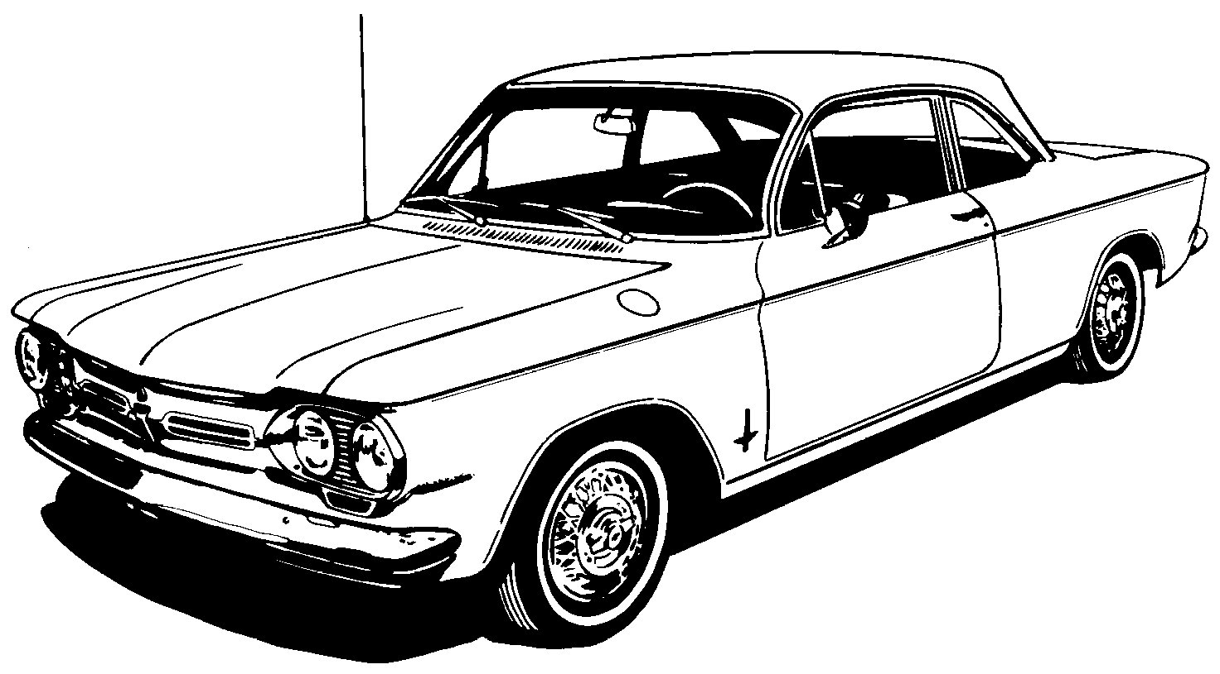

For information, call Steve Burns, 978/663-5022, A65Corvair@comcast.net

