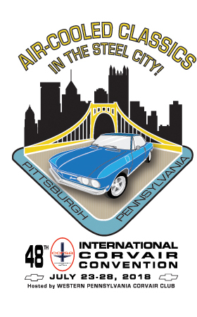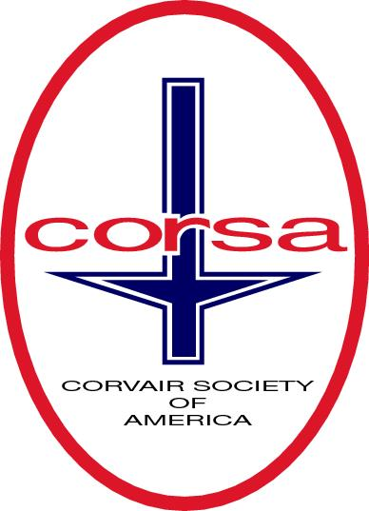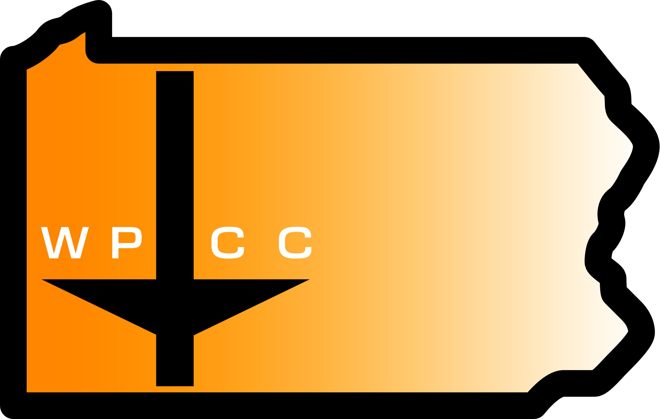
WESTERN PENNSYLVANIA CORVAIR CLUB
2018 CORSA CONVENTION UPDATE 11/24/17
WWW.CORVAIRPITTSBURGH.COM

Fellow Corvair enthusiasts,
I would like to thank the team from CORSA, Harry Jensen, Mike Hall, Larry Claypool, Ray Morales, and Allen Lacki (on Saturday), that came to Pittsburgh on Nov. 2-4, to help finalize a lot of items pertaining to the convention budget, and schedule. I would also like to thank all those committee chairs, the steering group, and helpers that showed up at Vincent's Restaurant in Greentree for the welcome meeting. Some of the highlights and changes of that weekend are as follows;
The concours d'elegence will be held in the upper parking lot at the hotel. The reasoning is if we are to showcase Corvairs to the conventioneers and the general public, we should put the over 150 cars for the car display on Saturday in a better setting, than just the 40 or so cars in the concours d'elegence. Keep in mind the concours cars will also be included in the car display show.
The car display show on Saturday will be moved to a more appropriate place closer to downtown. This place has not been determined yet. We are working with VisitPittsburgh (visitor's bureau) to locate a venue. This is the only big item still up in the air.
The autocross will be at the Mall at Robinson, in the parking lot behind Macy's on Friday.
Looks like a go on the added items that we decided to have, that have not been a usual event at most conventions. They include a, Ice cream social, outdoor movie night, and a Funkanha.
The welcome party will be just that. It will include an orientation for new comers, and lay out what's ahead for you in the coming week. We plan to have some type of entertainment, and the h'orderves will be a small "taste of Pittsburgh" theme.
The air-conditioned Sports Dome will have the indoor vending, daytime hospitality, and the Model car display inside. We will also have a night time hospitality area.
With some adjustments with the budget numbers it looks to be a profitable convention.
Some of the concessions we made mostly concerned trophies, and some event scheduling.
Thank you also to the staff at the DoubleTree Hotel, in Greentree. They worked with the group over the weekend on touring the facility, and honoring our request to change some meeting rooms, etc. around.
There have been some security issues at some conventions. So, we have the o.k. to have an armed guard at the event for night time security. After hours you will be required to have your convention badge and/or I.D. on you, if questioned.
I have been in touch with Clarks Corvair parts, and they are bringing their complete convention display. They did not do this at last year's convention. They will not be buying cores though.
I have been busy adding content to the convention website for the event schedule, and also the "self-guided tours" venue section. The two group tours, Tuesday 's Gateway Clipper dinner cruise, and Thursday's Pirate baseball game, are the conventions "official" tours. With so much to see or do in Pittsburgh, we couldn’t justify leaving anybody's requests out. So, we decided to have a bus run from the host hotel to different areas of Pittsburgh, on different days, on an hourly loop. We are calling these the "own your own, self-guided tours" On Wednesday, the bus will make a loop to the North Shore/ Station Square areas. On Thursday, it will make the loop to the Strip District/Cultural District/Downtown/Oakland areas. There will be a charge of $5 per person, per day, but this is a cost savings over the aggravation and price of a parking spot. Conventioneers will have sites and venue information in their goody bags, it will also be available to them at the registration desk, and at hospitality. These will be added to the website very soon.
Our first convention information will be in the next Communique, and we have been busy on that.
The excitement must be catching on. I have had contact and requests from a few groups that would like to have their own area, or idea at the convention. The v-8 Vair group wants to have a designated area, and are saying 6-8 cars already. Are you listening John Black?
The Yenko stinger people also are stating that they could have a good turnout as well. Are you listing Warren and Walt?
The corvair Jr people (the little go cart cars) may have their own area, and may run them in the Funkanha.
The raffle car ticket sales are coming along nicely. We plan to take it to the upcoming events; World of Wheels in Pittsburgh; Helen, Georgia corvair meet; the Recall corvair meet in Syracuse, New York; and the Pittsburgh Grand Prix, along with many local car shows and cruises this coming year.
As always keep informed at WWW.CORVAIRPITTSBURGH.COM.

Thank you,
Jim Weppelman
WPCC Secretary, 2018 CORSA convention local chairman

