Great article on Hemings.com: 1966 Chevrolet Corvair homecoming
Don Homuth
March 6, 2019

https://www.hemmings.com/blog/2019/03/06/1966-chevrolet-corvair-homecoming-the-good-news-and-the-bad-news/?refer=news
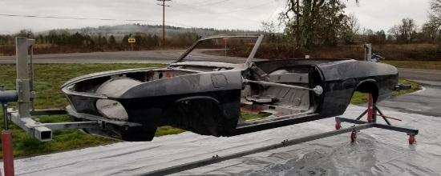 | 1966 Chevrolet Corvair homecoming – The good news and the bad news - hemmings.com  Gary Ludwick says: March 7, 2019 6:34 pm. Was a 25 year old in his first job and was in love with the 66 Corvair, especially the convertible. Had the down payment and was ready to sign on the dotted line.  www.hemmings.com

