I just ran across this old note that seemed to be a beneficial point of view. It can happen to anybody!
Fran

My 3100cc CORVAIR engine Monday, January 30, 2012
3100cc VW jugs and pistons with floating wrist pins….a roller cam with hydraulic lifters [the lifters are modified to increase the oil flow to the rockers] and roller rockers. Photo shows the engine in red as it was intended for my RED car. Vince Rohr did a lot of this RED powder coating.
I have been bench running my 3100 for about a week now. Checking leaks and searching for clicking sounds, etc. Today I revved it up a bit and opened the Secondary a bit and made a lot of noise…a bit. So, I hung a pair of old mufflers under it – much better! It sounded good but didn’t have that whip I wanted when I crack the throttle. By setting the timing ahead some more I got some more snap but as soon as I ran it up it would bog. If I ran one carb up to about 3000 and then cracked open its secondary the engine would backfire and bog even worse……one consolation was that it did it on both sides. I did not like the way it ran. I put the timing light on it to see how far off of 20 degrees advance I was, and it was close, so I left it alone. I was still holding the timing light in one hand when I blipped the one carb up a bit. The advance that was indicated by the light - - went away! A little more checking and no matter what I did the timing would back up - -nearly to TDC @ 4 grand! It did not want to run there ….. and neither did I!
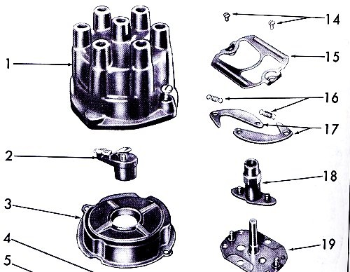
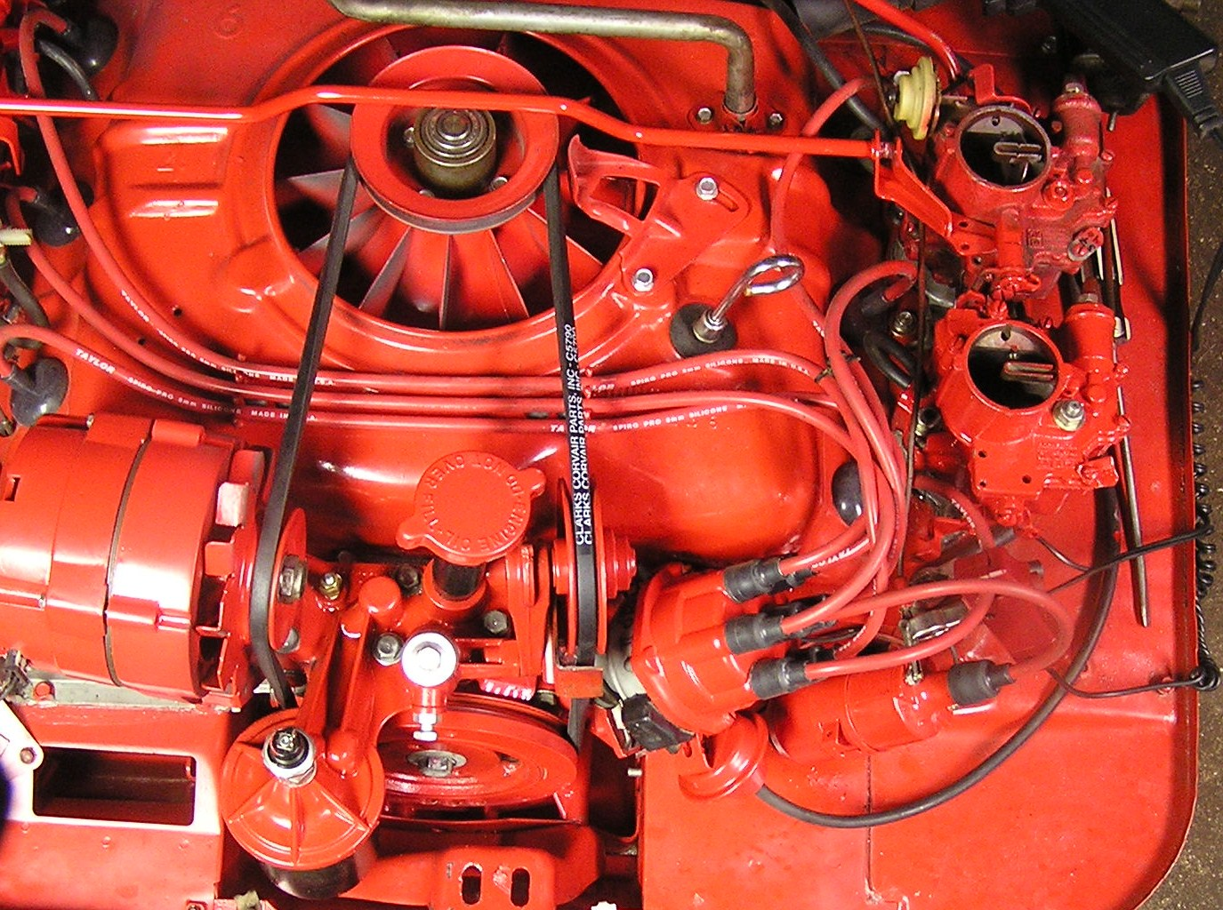
I took off the dist cap and inspected the weights that cause the mechanical advance - - I took them off and turned them over so they would go the other way…. but they wouldn’t fit in the dist that way, so I put them back on. Ran the engine and it repeated the retarding effect - - at speed.
I opened the dist again and took out the weights and said, “you guys are going in on the other side!” They didn’t fit! I removed the cam assembly (see #18 in the shop manual photo) to see why it would not allow me to put in the weights and found that the cam assy was installed in the dist – 180º off! I unplugged the cam assy and swung it around and plugged it in where the weights could fit and replaced the springs, etc. I figured I was home………but now the engine would not start!
When I moved the cam assy around to the other side that also moved the rotor from number 1 to number 2, pointing the rotor to the other side. I pulled out the dist and rotated the shaft 180º and dropped it back in. BINGO! Now she runs.
The best part is that now the timing advances when I rev it up and I can rev the hell out of it and add the secondary to get even sweeter MUSIC!!! It really purrs up there in the high ranges…VROOOM.
I may be ready to install this baby in to my new(er) ’66 2dr 500….. In the old days this would have been called a “sleeper” but nowadays nobody knows a Monza from a 500 so the point is “moot”. I think I will put this incredible engine into my ’66 and get it out to the Dyno people for a test run. That will be fun!
Keep on CORVAIRing!
Fran Schmidt

