2023 Corvair Tri-State
May 19-21, 2020
Salida, Colorado

The Pikes Peak Corvair Club (PPCC) is proud to announce that registration is now open for the 38th Tri-State meet to be held in Salida, Colorado the weekend of May 19th-21st, 2023. The host hotel is the completely renovated Hampton Inn & Suites, located at 785 E. Highway 50. PPCC has secured a Tri-State special rate of $119/room plus tax for either a King room or a double Queen room. Breakfast is included. To register for the event, order tee-shirts, reserve a room, and sign up for the banquet to be held Saturday night, please log onto the PPCC website https://pikespeakcorvairclub.wixsite.com/ppcc and click on “2023 TRI-STATE” on the top menu banner. This will open the information page with all the information you need to do on-line registration, or to print the registration form. There is also a direct link to the hotel registration site to register at the hotel and a schedule of events and times.

If you have any questions, please email ppcctristate@gmail.com. We look forward to seeing you there at the Tri-State next year in Salida, the Heart of the Rockies.

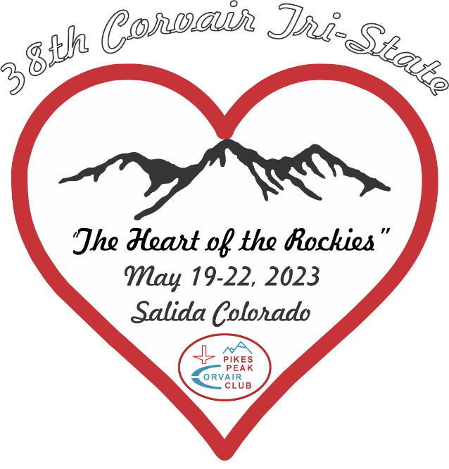

ppcctristate@gmail.com

