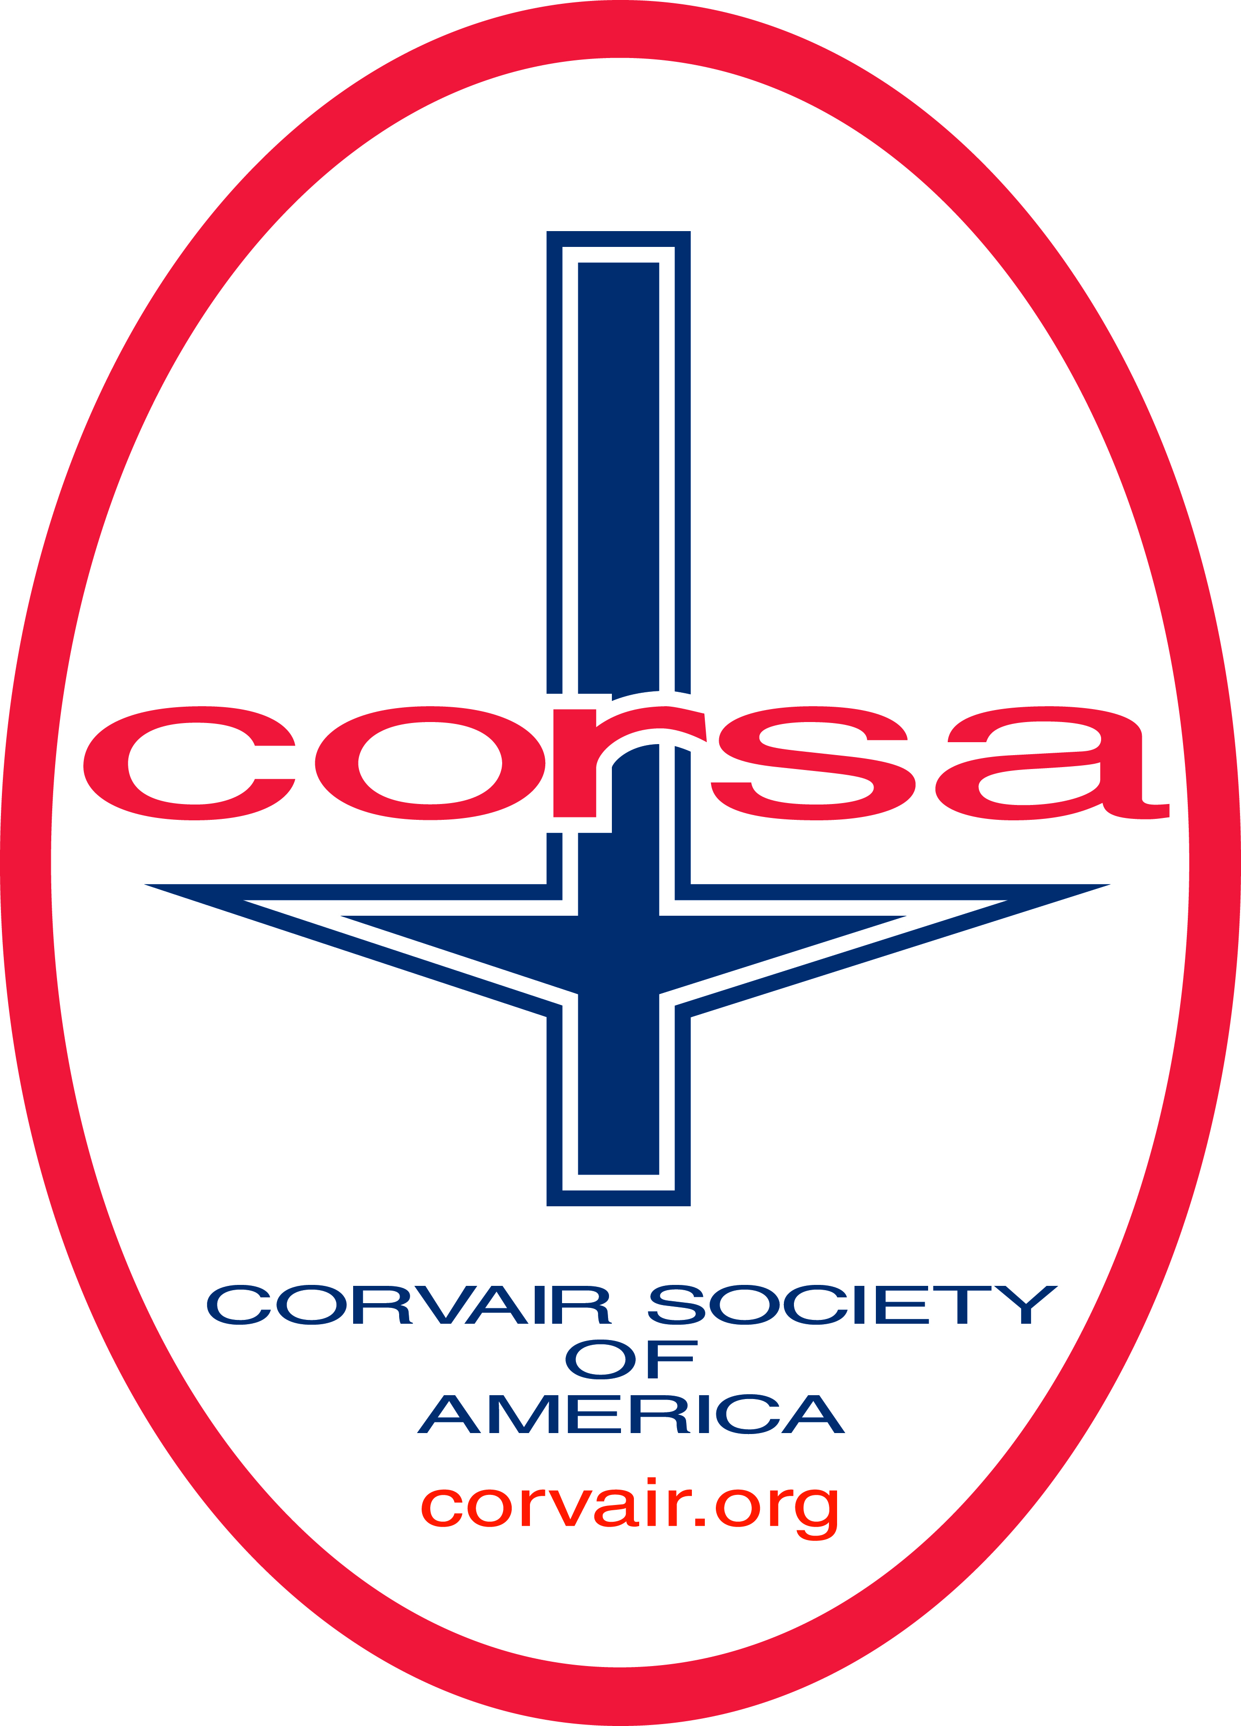
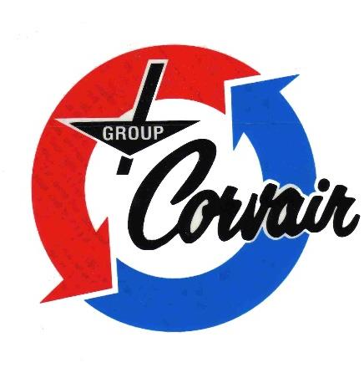

Group Corvair
Comments
GROUP CORVAIR’S NEWSLETTER FOR THE NATIONAL CAPITAL AREA

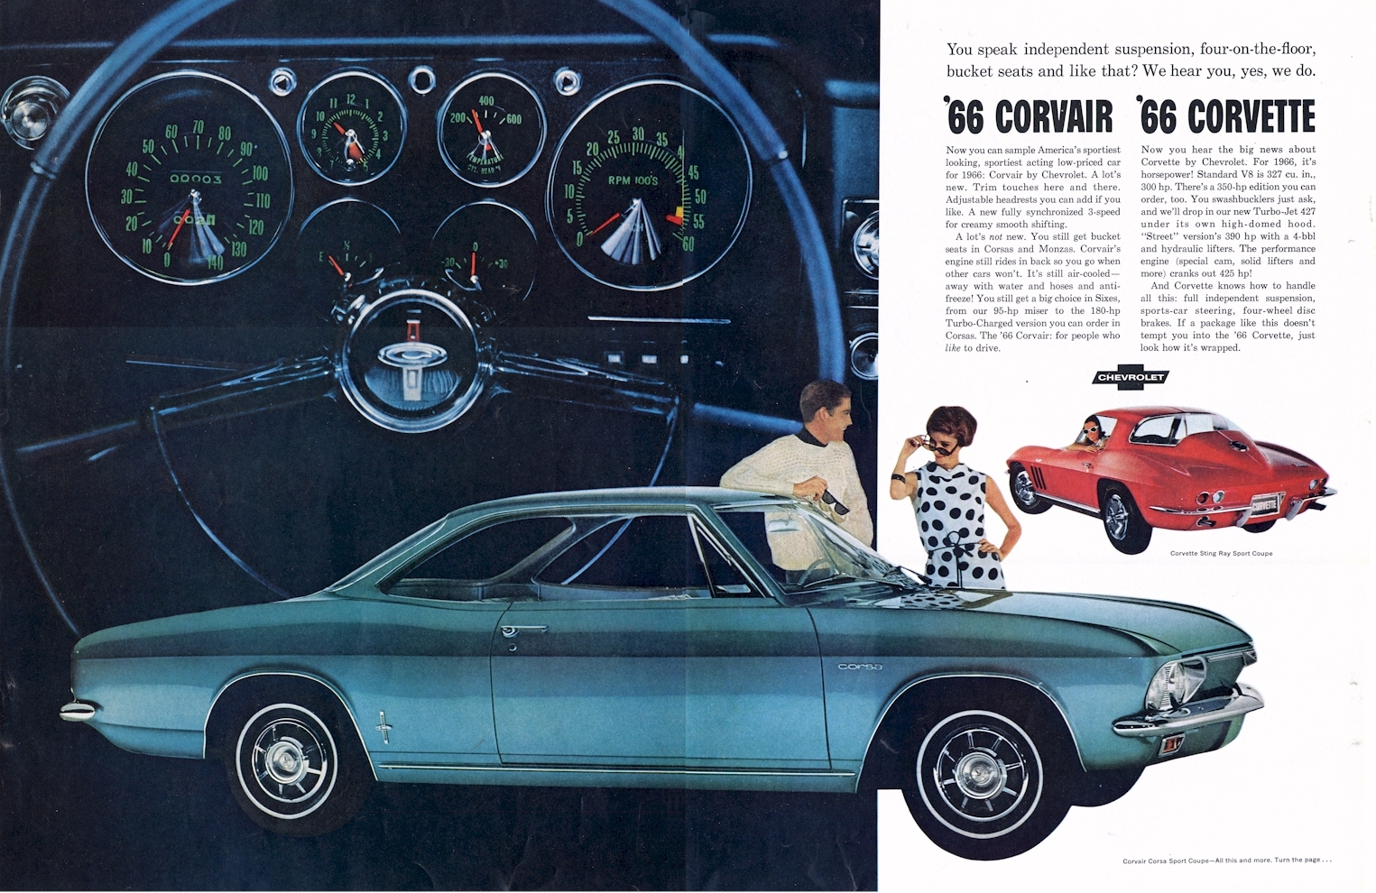
VOLUME LIII, No. 3 March 2025
Membership Dues are OVERDUE! Dues are $10 per year. Send your checks to Jim Simpson, 3845 Wayson Rd, Davidsonville, MD 21035.

CALENDAR OF COMING EVENTS

March
18 -- Group Corvair On-Line Meeting. 7:30 p.m.

April
15 -- Group Corvair On-Line Meeting. 7:30 p.m.
26 – 42nd Virginia Vair Fair. 9 a.m. – 3 p.m., Kitchen 33 Restaurant, 13155 Mountain Road, Glen Allen, VA 23059. This is just off I-295 on the north-west side of Richmond, VA. (From the DC area, south on I-95 to exit 84B onto I-295 West. Then exit 49A, onto US-33 West [it’s actually toward the north]. Kitchen 33 will be about ½ mile on the left.) People’s choice, model cars, parts vendors, buffet lunch and special Corvair memorabilia. Contact Frank DuVal, 540-273-6915 or corvairduval@cox.net to register.
26 – Southern High FFA Car, Truck, and Tractor show, Green Turtle, 3213 Solomons Island Rd., Edgewater, MD. 10 a.m. – 2 p.m. $20 registration, supports Southern High School agricultural education program.

May
20 -- Group Corvair On-Line Meeting. 7:30 p.m.
20 – 23 – CORSA International Convention. Note the change in venue to San Luis Obispo, CA.

June
17-- Group Corvair On-Line Meeting. 7:30 p.m.

July
10 – 13 – Detroit Area Corvair Club “Homecoming”. Ann Arbor, MI. Visit their Facebook page for more information or to register go to: http://detroitcorvairs.com/Homecoming2025.html
15-- Group Corvair On-Line Meeting. 7:30 p.m.

August
19-- Group Corvair On-Line Meeting. 7:30 p.m.

GROUP CORVAIR 2025 OFFICERS and Points of Contact

President: Bob Hall
4612 Franklin St., Kensington, MD 20895
301-493-8405 HallGrenn@aol.com
Vice President: Mark Shiffler
174 Dividing Ct., Arnold, MD 21012
443-770-4719 mshiphty@gmail.com
Secretary: Marolyn Simpson
3845 Wayson Road, Davidsonville, MD 21035
301-262-0978 or 240-232-2820 MarolynSimpson1@gmail.com
Treasurer: Jim Simpson
3845 Wayson Road, Davidsonville, MD 21035
301-262-0978 or 240-232-2820 simpsonj@verizon.net
Newsletter Editor: Jim Simpson
3845 Wayson Road, Davidsonville, MD 21035
301-262-0978 or 240-232-2820 simpsonj@verizon.net

From the Oval Garage
Bob Hall
March means Daylight Savings Time has returned and with it longer outside workdays to get our Corvairs back on the road. Mike Coale’s restoration of his ’66 air-conditioned coupe is making real progress in the body shop. Mark Shiffler, our club Vice President, is sorting through clutch problems that may have affected his transmission’s shifting so we’re optimistic that once the clutch issues are corrected his transmission will also shift like new. Jim and Marolyn Simpson have found an experienced body man to repaint their Corsa’s driver’s door to match the rest of the car. Our shared club tool inventory came in handy and provided a drum/disc puller for Jim to do some brake work on his (Audi) wagon.
Anyone need a Tech Session to help with a project of your own?
The 2026 Convention is progressing, and we urge Group Corvair members to take a look at the Wyndham Hotel site just off of US 15 at the Route 30 exit whenever you are in the Gettysburg area. The selected venue is near to so many attractions that a visit even before the convention would be well worth your time. The next online meeting of the sponsoring clubs that was tentatively scheduled for this past January has not yet happened, but planning continues. Group Corvair has sent the names of our club members who have volunteered to help to the lead club to be added to the convention database.
I’ve boxed up two AC PF4 oil filters, one each for Phil Richardson and Bob Walker, for their shared longest distance award at the February social dinner meeting and will get them to the Post Office in the next few days. We still hope to have another dinner meeting in March. We will get details out via email as soon as the details are worked out.
“See” you at the next Zoom meeting.

Minutes of the March Virtual Meeting
Marolyn Simpson
At 7:30 pm on February 18, Group Corvair members began logging into the monthly Zoom business meeting. While waiting for members to log in, Jim Simpson brought us up to date on the progress he has made toward getting his car repainted. There was also a discussion on membership dues.
Bob Hall called the meeting to order at 7:40 with six members present. Minutes of the January meeting were accepted as written in the newsletter.
Jim gave the treasurer’s report. Expenses for the last month were for the Corsa chapter filing fee. Several members have renewed their annual dues, but there are still some who have not.
With spring coming up we need to start thinking about tech sessions again. We still need to complete the work on Lorenzo Church’s Monza to install a dual master cylinder—hopefully this time with all the correct parts on hand.
When the weather warms up Mark Shiffler wants to get back to working on his car. He plans to take out the drivetrain and clutch since he’s been having problems with clutch chatter and hard shifting. Then he can look and see what needs his attention.
Mark is working on a roster of Group Corvair members. It will contain a picture(s) of each member’s car(s).
Bob H. will check out places for a social event during March. Comments on the February social gathering at Nonna Angela’s were all positive. Everyone seemed to have a good time.
Jim has the club tow bar. If anyone needs to tow a car, let Jim know.
We are looking for a webmaster to build a Group Corvair web site. Hemmings and Corsa are possible hosts.
Bob Walker talked about a book by Jim Hall on racing that he had gotten as a gift. The car used power glide. Bob thought the pictures were particularly good.
We have received no further word from the 2026 convention committee.
The meeting ended and we logged off at 8:34 pm.

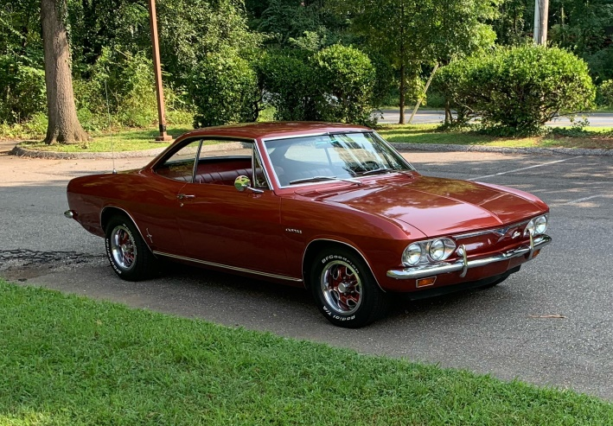
Corvair Restoration Update 9
Mark Shiffler
1966 Corsa Restoration or the never-ending saga of finding the gremlins. Since I got the car back on the road last spring, I have been able to accumulate about 500 miles on the car, including the Rock Hall Car Show. During that time the car has had a constant problem with being hard to shift, particularly the 1-2nd shift, and clutch chatter. Since the weather was breaking, it was time to pull the driveline back out and start trying to figure out what was wrong.
With the car back in the garage and up on jack stands I successfully removed the drive line, only breaking the backup light switch in the process (Clark’s is sending me a new one). I have a motorcycle jack which does a great job of balancing the engine and a small dolly to hold up the transmission end.
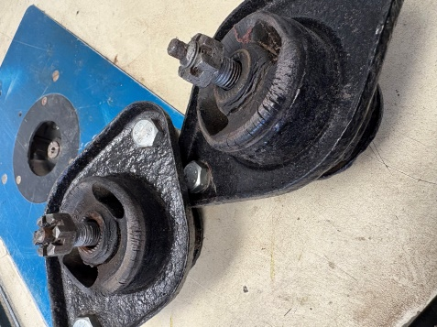
First up, with everything out of the way, was to replace the forward engine mounts. I should have done it the first time I had everything out, but for some reason I decided they were OK to reuse. This time I bit the bullet and purchased new ones and did the change out. From the looks of the old ones…I think this was a good decision. You can see that the 1966 originals were breaking around the center bolt.
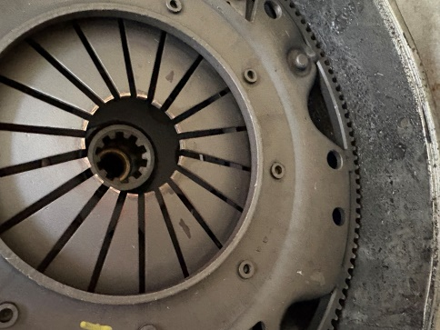
After I pulled the differential/transmission from the engine the pressure plate was showing and clearly something was amiss. I put 2 marks on the fingers, one at about 4 o’clock and one about 7. The fingers on the lower side of the circle are about 1/16 to 1/8 inch below those on the upper side. The bronze-colored wear strip on the tips of the fingers was much less on the lower fingers than on the top fingers.
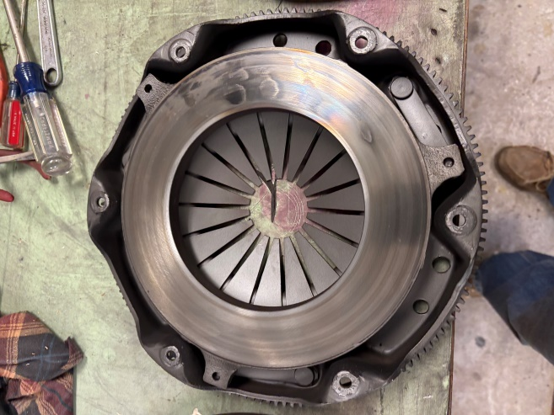
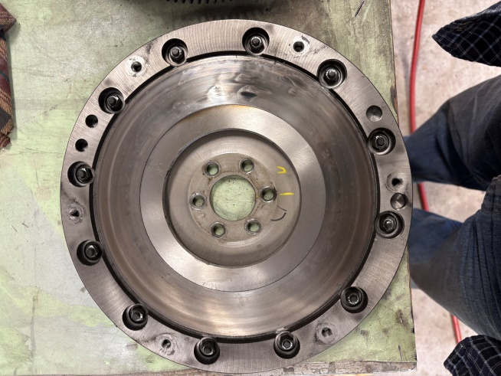
The throw-out bearing, while a little beaten up around the fork area, was smooth and was reusable. When I separated the pressure plate from the flywheel it was evident there were wear spots consistent with early contact of the clutch disk that might create chatter. I also pulled the side plate off of the transmission but could find no evidence of any abnormal wear on the synchronizer pieces or the gears. Jim Simpson came over and we both went through the transmission and clutch pack and decided the clutch was the overall culprit. The disk looked fine, but the pressure plate and flywheel needed to be replaced or re-machined.
A big thank you goes out to Corvair Ranch, who I originally purchased the clutch parts from in mid-2023 but has agreed to replace the parts. I’m going up next week to make the trade, then a week to two to put it back together.
Hopefully next month I can tell you everything is back together and working as it should.

Tech Topics
Problems with Late-Model Brake Hoses. Mike Coale reported he’s been having a problem with the front brake hoses he’s been getting from Clarks Corvair Parts lately. It’s not entirely clear if it’s an issue with the reproduction brake cylinders or the hoses, but he’s found clearance issues between the hose and the wheel spindle that prevents the hose from threading into the brake cylinder. He’s solved it by grinding a bit off either the spindle or the hose connector, but that’s hardly a great solution.
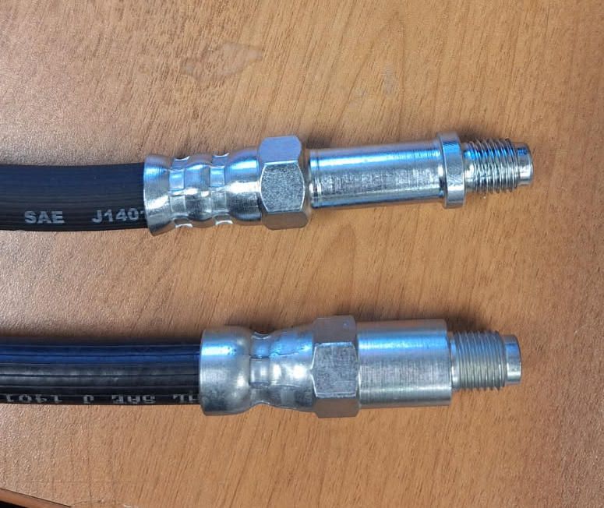
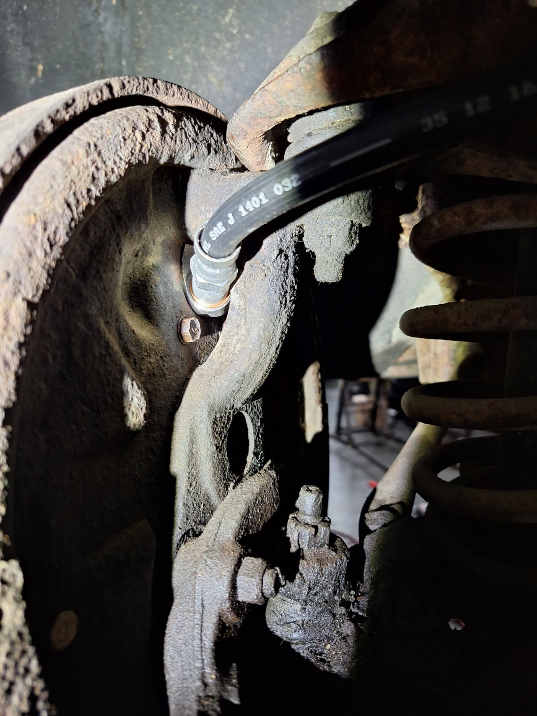
If you look at the pictures, you’ll see just how little clearance there is between the brake hose connector and the spindle. One of the cars Mike is working on had an older Dorman brand brake hose on it and the connector to the brake cylinder was necked down and fitted well. But the current Dorman catalog picture shows connectors that seem to be the same as the Clark’s hoses. (Dorman does have some with the necked down connector, but apparently not in the right length.)
We’re not sure where the problem is. It’s possible that the inlet on reproduction brake cylinders is slightly offset from the originals, hence the lack of clearance. Or it could be that the connectors on the currently available brake hoses are larger than the original GM design. Mike is thinking of contacting Dorman to see if they currently have brake hoses with the necked down connectors with the correct length for a Corvair.
Front End Bushing Replacement. By Fran, from March 2025 issue of The Leaky Seel, the newsletter of Corvair Minnesota.
I had decided to do a routine – every 40 years – replacement of my ‘67’s front end bushings.
The uppers when pretty much as planned. Then I go to take off that lower-inner pivot. Let me diverge for a second to remind the reader of the construction details of many Corvair pivots. Two concentric metal tubes are held together by vulcanized rubber. The outer tube is accurately sized to be pressed into a structure that moves. The inner/center tube is a piece of flat stock, rolled into a tube, but the split is not welded. This center tube has serrated ends so that it will grip – endwise – tightly when a structural bolt is sent through and tightened. Once tightened, the bolt and center tube do not move. All movement is handled by the rubber bushing between the two tubes. The reason I am pointing out the split is because that split saved the day for me.
Since most manufacturers never intended for these units to be on the road for 40+ years, they didn’t put grease inside that center tube. Without any protection, any rusting can – and will – take place inside this dark and hidden place. Rust is something like 35 times that volume of the iron it came from so the bolt and inner wall of that center tube, as they rust, become ONE!
As I was attempting to remove the bolt from the center tube, I met with gargantuan resistance. I was able to finally extract the first of the bolts with much brute force. But the second bolt was “married” to the center tube and would not budge. I used more brute force and turned the bolt and tube inside the rubber bushing, twisting back and forth thinking that magically the heat of my efforts would persuade the bold and tube to separate. No way! I was getting ready to take the entire crossmember off the car so I could torch that sucker! Then I remembered the split in the center tube.
Here's how I got them apart.
A small portion of the outer tube is accessible from below. I used a Sawzall to cut a few slits in the outer tube. When I broke out the piece of the outer tube, I had exposed about a half inch of the rubber bushing, which I then cut away. There was the center tube! I rotated the bolt/tube assembly until the split was visible in the hole I had made. A bit more brute force put the tip of a sacrificial screwdriver into the split. Once that split was compromised – expanded a bit – the “marriage” fell apart, and I was able to remove the bolt. Here’s a view of the camber adjuster bushing after the battle was won.
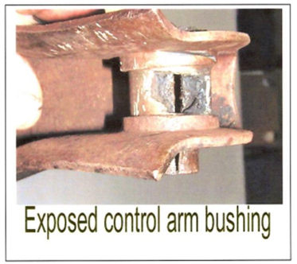
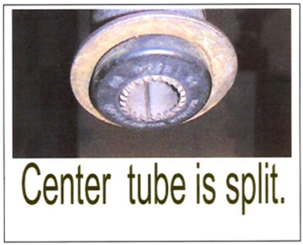
You better believe that the new bolt will be bathed in heavy duty lube upon reassembly!

Carroll Shelby and the Corvair Connection
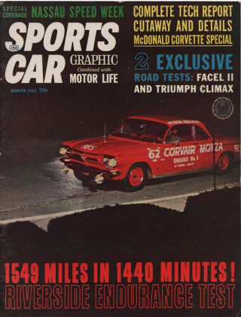
By Eva "Corvair Lady" McGuire, Creator/Corvair Historian, Meet the Makers of the Chevrolet Corvair, 7225/1/20/25. (via Facebook).
This article appeared in the June 2018 issue of Motor Trend, written by Drew Hardin, with photos by Bob D'Olivo, courtesy of Petersen Publishing Archives. (From the Central Virginia Corvair Club VAIRifiable News, February 2025)
Enjoy this article that was published in Motor Trend Magazine when Carroll Shelby had two early production 1962 Corvairs (one stock; one modified) prepped for a 24-hour Enduro test run at Riverside International Raceway:
"In November 1961, editors from several Petersen Publishing magazines, including Hot Rod, Motor Trend, Sports Car Graphic, Car Craft and Rod & Custom, plus some pretty heavy hitters in the racing community, gathered at Riverside International Raceway for what Hot Rod described as a “24-hour high-speed economy run” using two bright red ’62 Corvairs.
And we do mean heavy hitters: It speaks to the power of Petersen’s empire that guys named Unser, Gurney, and Shelby were on hand to help shepherd these two little coupes around Riverside’s winding 2.7-mile road course for what would be a “grueling 1,549.1-mile ordeal.”
Carroll Shelby conducted the test, acting as “sports car racing expert” and in his capacity as the chief of the high-performance driving school he hosted at the track. Chevy performance guru Bill Thomas prepped the cars. One was left mostly stock, having only such extra items as were deemed useful for safety,” like a Sun tachometer, EMPI front sway bar, Shelby-branded smaller steering wheel, dual Moon fuel tanks (to aid in accurately measuring fuel economy), Goodyear Blue Streak tires, and Lucas driving lights.
A second car got those parts too, but it was also fitted with Thomas’s four-carb induction setup, a Racer Brown camshaft, Hands magnesium racing wheels, sintered metal brake linings and open exhaust. They’re easy to tell apart in the photos by their numbers: 98S for stock, 98M for modified.
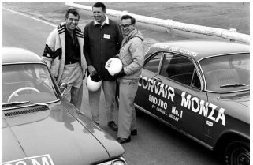
“The plan,” as Hot Rod described it, “was to allow each driver two hours behind the wheel, with predetermined averages posted as a target speed for each car, and with gasoline consumption and mileage carefully recorded for each hour’s tour.”
Petersen Editorial Director (and head of the NHRA) Wally Parks would start in the modified car and Sports Car Graphic Editor, John Christy, would take the maiden laps in the stocker.
The photo on the left (from Hot Rod’s March 1962 issue) shows Parks (center) and Christy (right) posing with a sweater-wearing Carroll Shelby at the start line.
Carroll Shelby (left) in photo with 1962 Corvairs at Riverside International Raceway. Note Carroll Shelby's name on the car.
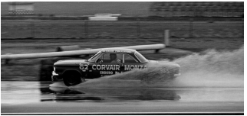
Things did not go as planned. After just the first hour, while the stock Corvair was “breezing along,” the modified Corvair was wounded. Upon inspection, it had developed “a mechanical failure not typical of Corvairs—a loosened key in a timing gear allowed the cam to retard, thus impairing the engine’s previously healthy output.” The car was pulled, though “it had already proved its potential, and speculation ran high as to what lap speeds it might have chalked up with Dan Gurney or one of the other scheduled pilots aboard.”
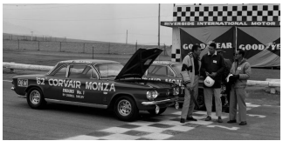
The stock car, then, became “the real star of the show.” Lap after lap “it steadfastly maintained its speed as the hours passed slowly by,” even during an 11-hour nighttime rainstorm that “made the track slippery and laden with deep puddles, testing the skill of the drivers and adding to the event’s challenge to the Corvair.”
At the 24-hour mark, the stocker had run 1,549.1 miles at an average speed of 66.3 mph. Fuel economy was 16.6 mpg, “despite the fact it was driven at speeds varying from 40 mph on some turns to 105 mph on the straightaway.” Just one quart of oil was added during the test, and the “stock brakes were as good as new.”
In the end, “contestants and observers agreed this was one of the most demanding controlled endurance tests ever encountered by an American stock car, and Corvair won a flock of new admirers as a result.”
1962 Corvair Monzas with Carroll Shelby at Riverside International Raceway.

Vair Vendor
For Sale: Early and Late Parts:
’64 3.27 differential, $40; ’64 3.27 4-speed transaxle, $100; ’64 Sypder engine lid, $120;
‘64 Convertible top frame, $65; ’64 4-door NOS left quarter panel (GM # 6279405), $200
’64 2 each front cross members, complete with brakes, shocks, springs. Very good condition: one from a Sypder, $175, other $150; ’62 – ’64 Convertible rear quarter window glass, left and right, $30
’65 – ’69 underbody plastic heater duct, $30; ’65 – ’69 Convertible corner weight, $15
? year – Engine cover with fan bearing, $20; 3 standard transmission bell housings, $30 each.
Free – CORSA Communique from 2016 through 2023. Pickup or mail ($14.38 for USPS).
Prices are negotiable. Contact Bob Lewis, 301-246-4278, rtl1936@gmail.com. (5/23)
For Sale: Mike Coale is thinning his collection: He’s constantly acquiring cars and parts and likely has what you need and maybe even something you didn’t know you needed! Contact Mike Coale, mikecoale@verizon.net or 443-994-2559 and see just what he has available.

Corvair Part and Services

Clark’s Corvair Parts
400 Mohawk Trail, Shelburne Falls, MA 01370
413-625-9776
www.corvair.com
--------------------------------------------------------------------------Eddie Meadows Automotive
991 Foxfire Trail
Oviedo, FL 32765
407-36-09748
--------------------------------------------------------------------------Handy Car Care – Ken Hand
1896 S. Gregory Rd.
Fowlerville, MI 48836
248-613-8586
www.corvairmechanic.com
vairmech@aol.com
--------------------------------------------------------------------------Bill Cotrofeld Automotive, Inc
3630 Route 7A Arlington
P.O. Box 235
East Arlington, VT 05252
Call or write for a free brochure.
802-375-6782
-----------------------------------------------------------------------------
Corvair Ranch
1079 Bon-Ox Road
Gettysburg, PA 17325
717-625-2805
https://corvairranch.com/
----------------------------------------------------------------------------Wolf Enterprises
32605 Rhode Island Ave.
San Antonio, FL 33576
E-mail: GyoungWolf@earthlink.net
352-588-0645
--------------------------------------------------------------------------S & S Corvair Parts
Bill Slusher
1816 Laurel Road
London, KY 40744
Phone 606-878-2862, Text 606-224-2207
----------------------------------------------------------------------------------------------------------Corvair Parts
Nos Late Model
Used All Years
Pete Claffey - Cell 706-830-2818
----------------------------------------------------------------------------------------------------------California Corvair Parts
15090 La Palma Dr., Chino, CA 91710
951-284-3555
www.CaliforniaCorvairParts.com
----------------------------------------------------------------------------
