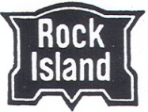
ººUpcoming Eventºº

In October 1888, the Rock Island Railroad yard included a depot, 14-stall roundhouse and turntable, water tank, pump house, coal trestle with 24-pocket coal chute, coal house, two oil houses, stockyard and coach repair shop. JOIN US this October to celebrate 130 years of Rock Island history at our roundhouse.
ROCK ISLAND DAYS
celebrating 130 years of rock island history in roswell
SATURDAY, OCTOBER 20, 2018
10 A.M. - 4 P.M.
2333 Steel Drive, Colorado Springs
Tours, Trolley Rides, Exhibits, Model Train Layouts, and Operation Lifesaver
11 a.m. - 1 p.m.: Free lunch and anniversary cake (donations welcome)
Admission: $3.00

