ALBUQUERQUE ATTRACTIONS

Here are just a few of the many fun and interesting things to do in and around Albuquerque

OLD TOWN – The center of the original village of Albuquerque features a pleasant plaza surrounded by shops, restaurants, and a beautiful old church.
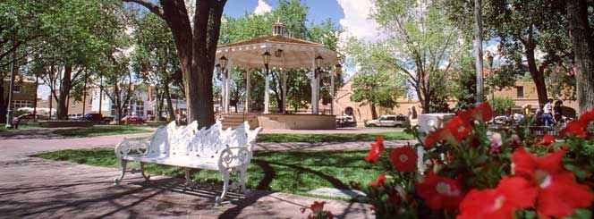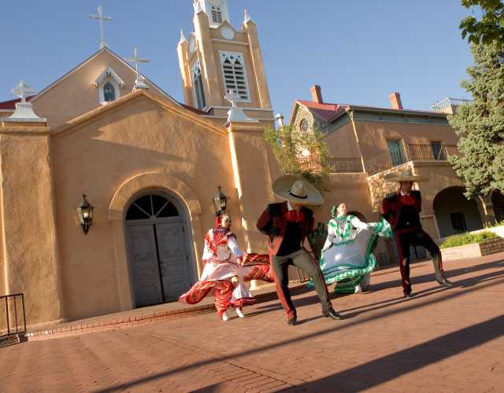

SANDIA TRAM – The second longest tram in the U.S., it takes you to the top of the Sandia Mountains for a view of Albuquerque that is breathtaking. The new restaurant at the peak is scheduled to be open by this October.
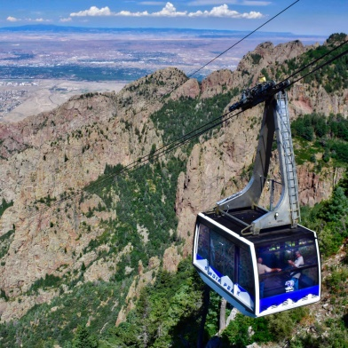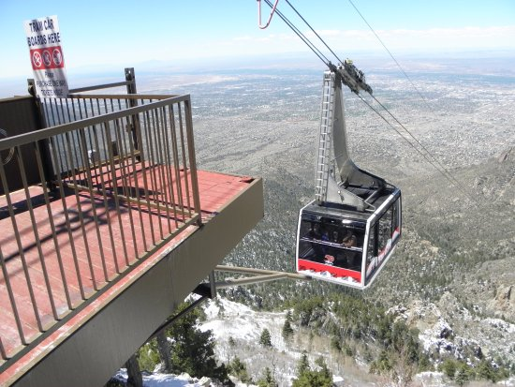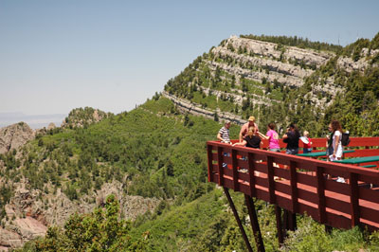

UNSER RACING MUSEUM
All the cars raced by the Unser family in an interactive setting, along with a collection of antique cars and Unser trophies and racing memorabilia. Al Unser Sr. is often there to meet with visitors.
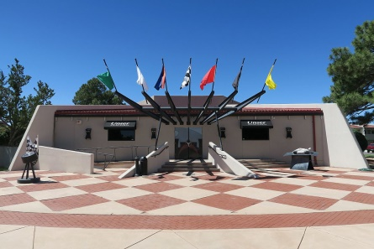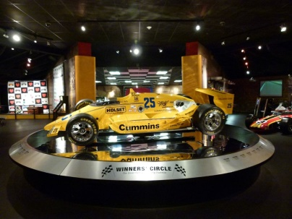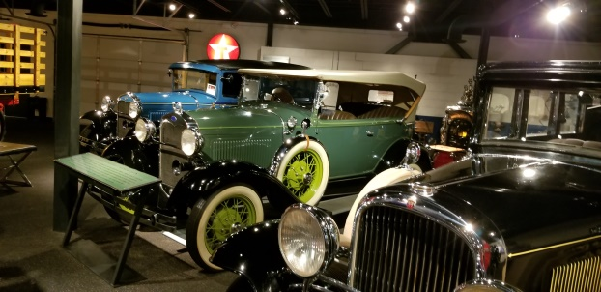

TINKERTOWN
Tucked away on the east side of Sandia Peak, Tinkertown is hard to describe, but worth the visit. An old ranch house was converted by its hippie artist owner into an eclectic museum of folk art and odd collections, including the sailboat his brother took around the world. They have the most unusual gift shop ever.
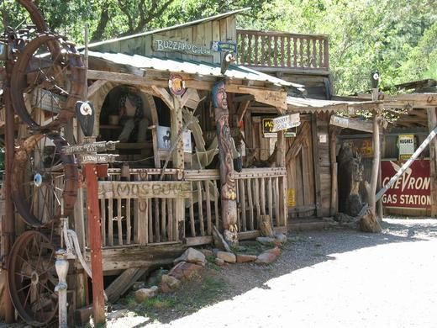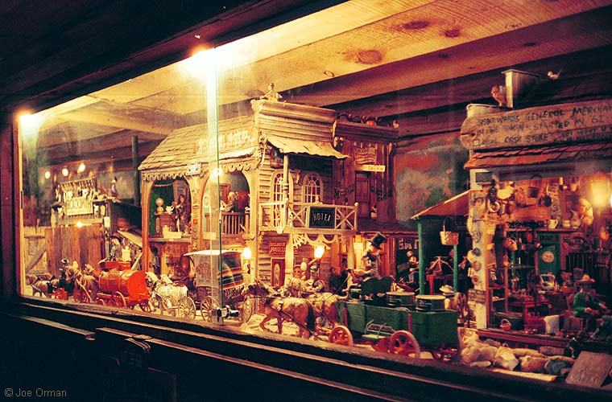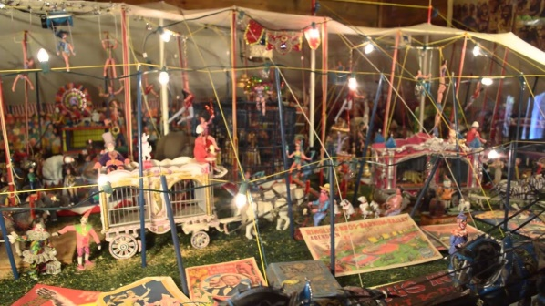

MADRID
Madrid was an old mining town that became a ghost town, and then in the seventies became a hippie commune. Now it is an artist colony, and the location for the Tim Allen/John Travolta movie “Wild Hogs.” It has many shops and a great biker bar called the Mine Shaft Tavern.
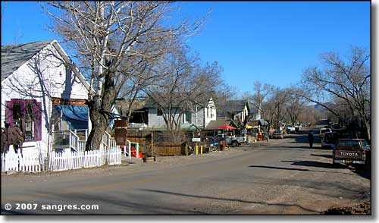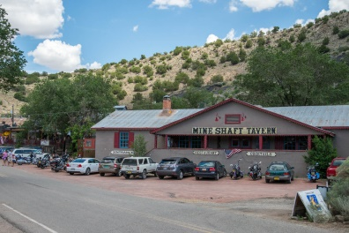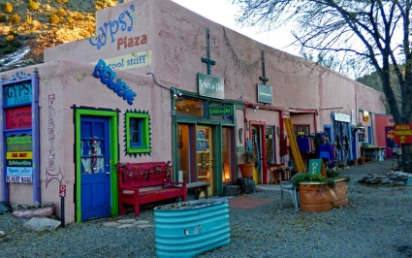

ZOO/BIOPARK
Albuquerque has a beautiful zoo only blocks from Old Town, and even closer to Old Town is the Aquarium, Bugarium, Butterfly house, and one of the best Botanical Gardens you will ever visit.
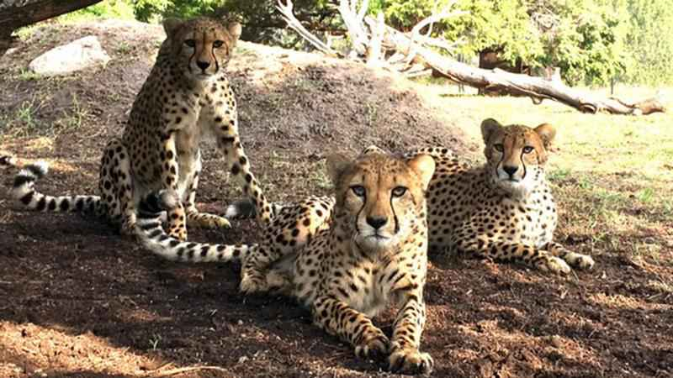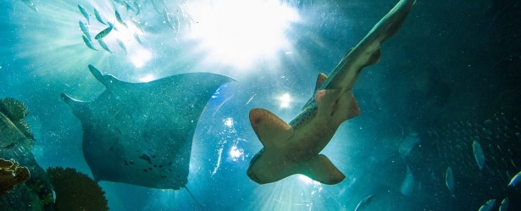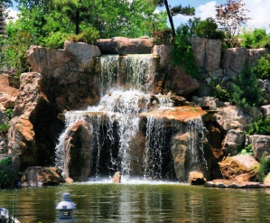

NATIONAL MUSEUM OF NUCLEAR SCIENCE
Everything you ever wanted to know about nuclear weapons and their delivery systems.
