1st Annual
Black Feather District
Pinewood Derby
and
Car Show
April 4, 2020
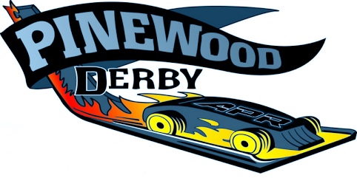

Sponsor tables will need to be set up prior to race. Approximately 9:00 AM
Show cars will need to be parked before Cub Scouts begin to arrive. About 8:00 AM
Event will open at 7:00 AM close at 4:00 PM
Douglas County Fairgrounds Multi-Purpose Barn North
500 Fairgrounds Rd Castle Rock CO 80104
Contact Bob Disher Broncobob78@msn.com or 303-995-3474 cell

Boy Scouts of America

Denver Area Council

Black Feather District

Serves the following school districts: Douglas County, Littleton, Sheridan, Englewood and Elbert County

BSA Mission Statement
The mission of the Boy Scouts of America is to prepare young people to make ethical and moral choices over their lifetimes by instilling in them the values of the Scout Oath and Law.

BSA Vision Statement
The Boy Scouts of America will prepare every eligible youth in America to become a responsible, participating citizen and leader who is guided by the Scout Oath and Law.

