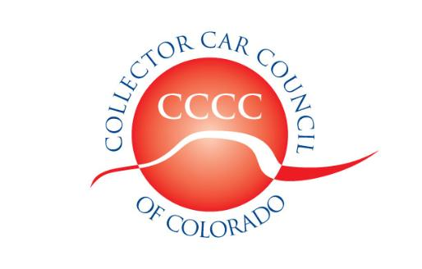

Collector Car Council of Colorado, Inc.

Dedicated to the preservation of automotive history

www.collectorcarcouncil.com

President: Dick Thompson, Mile High Cobra Club 303-699-4819 Thompson660@cs.com
1st Vice Pres: Tom Mansfield, Looking Glass Corvette 303-901-3682 tommans@outlook.com
2nd Vice Pres: Samantha Baker, So.Colo.MOPAR 303-726-2826 Bakersams@msn.com
Secretary: Dick Fritz, MG Car Club 303-774-9710 RBFritz@comcast.net
Treasurer: Tom Mansfield, Looking Glass Corvette 303-901-3682 tommans@outlook.com
Legislative information: Leo J. Boyle 303-321-6611 Leojboyle@aol.com
Political Committee Liaison: Ted Rossi 303-618-3935 Tedrossi@q.com
Web site liaison: Chuck Smith, No.Colo.Model T 303-973-9915 herbnut@aol.com
SEMA Show coordinator: John Ehrlich, ColoRODans 303-526-6805 Altechprec@yahoo.com

Minutes of Meeting, 7 April 2021

Due to Corona-19 virus concerns, this was a “hybrid” meeting, partially in-house at the Hagerty Garage, 8101 Shaffer Parkway in Littleton CO and partly via Zoom over the internet. The meeting got underway at 7:32 and was preceded by an Airport Show Committee meeting.

Our host for this meeting was William Roushey who described Hagerty’s interest in promoting the car collecting hobby in ways in addition to selling collector car insurance. He stated that the garage is available for use by car clubs for meetings or as a starting point for tours, etc.

Legislative: Leo Boyle reported that the Colorado Legislature is about 50% through its 2021 session and will conclude in mid-June. He described several current bills but none directly affect car collectors. Air quality concerns target industry, usually gas and oil refineries, well heads, and pipelines. Control of greenhouse gasses and air toxics are emphasized, but transportation sources are not mentioned. Notably missing are references to title 42 (Vehicles and Traffic) of the Colorado Revised Statutes. One bill that was already killed (“delayed indefinitely”) is HB21-1205 which proposed an “Electric Vehicle Road Use Equalization Fee”. Dick Thompson expressed concern about HB21-1083 which modified on appeal property taxes set by counties. Aircraft owners have suggested that this may raise taxes on hangers that have been upgraded and likewise elaborate garages for collector cars.

Minutes: Official minutes of the March 2021 meeting were approved as published.

Treasurer’s Report: Tom Kay reported balances as of the end of March:

Operating Account: $ 1750.53
Govt.Relations Account: $ 3218.00
Swap Meet & Car Show Account: $ -800.00
Total funds, All Accounts: $ 4168.53
Reserve: $ 22630.33
Total: $ 26798.86

We have received renewals from 39 clubs. Mailing lists (internet and USPS) are updated as renewal forms come in. The club contacts on the web site have been changed as new representatives are listed. Clubs should check the club information on the website (www.Collectorcarcouncil.com) and notify the website liaison (Chuck Smith) to correct any incorrect information.

The treasurer’s report was approved as presented.

Airport Show and Swap Meet: John Mack noted that the 2021 Rod Run calendar lists our original date of August 14 rather than August 7, but this was because the Rod Run calendar was drawn up in October 2020 and the airport notified us in February that the August 14th date was not possible. Flyers for the event show the correct date of August 7. We have full support from Rocky Mountain Metro Airport (formerly Jeffco Airport) and coordination with Spartan College, the Rocky Mountain Renegades, the Civilian Air Patrol, the Commemorative Air Force, and local law enforcement agencies have all gone well. For our part, CCCC will need volunteers to promote the event at area car events, to handle swap meet registration, and various cleanup operations. Car Shows Inc. (CSI) will handle the Car Show. Contact Dick Thompson to say where you can help. Great Benefits for all volunteers.

Renewals: CCCC will send out reminders to clubs that have not sent in their 2021 renewals.

SEMA: SEMA is still planning to hold the 2021 SEMA Show in Las Vegas November 2-5. We have not heard officially how many complimentary passes may be available for CCCC members. If you are interested contact John Ehrlich at Altechprec@yahoo.com. In 2019 we were limited to 12 passes. SEMA’s email news lists legislative issues in other states, and several states are currently discussing single license plates.

Next Meeting: Not yet set.

Adjournment: The meeting ended at 8:26 pm.

Respectfully submitted, Richard Fritz, secretary A

Please remember to comply with guidelines to avoid covid-19. Get vaccinated, wear masks, maintain social distancing, wash hands frequently, etc. The sooner we can scale back the corona virus pandemic, the sooner we can get back to holding open collector car events and even an All Star baseball game.

