GWFBT 2025
Event Planning Document
Event Overview
- Event Name: The 47th Annual Great Western Fan Belt Toss & Swap Meet
- Website: gwfbt.com
- Date: October 24- 26, 2025
- Location: DoubleTree by Hilton Golf Resort Palm Springs, Cathedral City, CA

Event Lead: Sasha Agroskina (347)-204-0428
Coordinators:
- Registration: Sasha
- Vendors: Val Doppenberg
- Friday Dyno: Scott/Kregg (Inland Empire)
- Friday Cruise: Brad (Vintage Corsa)
- Friday Welcome Party: Sasha & Nettie (SCC)
- Car Show: Byron Linford (Utah)
- Games: Dave (Cactus) and Chuck/Nettie (SCC)
- Field Raffle: Mike Evans (San Diego)
- Gift Basket Club Competition: Sasha & Mike Evans (San Diego)
- History/Displays: Bill & Margarita (Corsa West)
- Other Activities: Val Doppenberg
- Banquet: Multi-Club
- Sunday Event: Sasha & Val
- Graphics & Merch: Scott Howey (Inland Empire)
- Advertising: Sasha
- Finances: Ronda (Vintage Corsa)

Meeting Agendas:
9/9 Zoom Meeting:
- Updates
- Review Planning Document
- Discuss Coordinators
- Gather input and ideas
9/23 Zoom Meeting:
- Updates
- Review Planning Document Changes
- Review Vendors
- Review Schedule
10/1 Meeting:
- Update on meeting with Hotel (9/30)
- Review Map
- Budget Discussion/Show Improvement ideas
- Judge Selection for car show
10/7 Meeting:
- Update on #s
- Run of Show for the Banquet
- Judge Selection for car show
10/14 Meeting:
- Update on #s
- Car Show Judges and updates
- Schedule updates
- Catering Updates/Decisions
Next Meeting 10/21 @ 5PM:
- Final Meeting!!

10/14 Update:
Registration | 158
Car Show | 71
Vendor - Main | 33
Vendor - Premium | 9
Vendor - Indoor | 8
Banquet | 184
Welcome Party | 176
Friday Cruise | 63
Sunday Event | 30
Valve Cover Race | 14
Dyno | 13
RV camping | 3
Big Raffle | 218
T-shirts | 98

10/7 Update: 10/1 Update:
Registration | 150 |  | Registration | 131
Car Show | 68 |  | Car Show | 62
Vendor - Main | 31 |  | Vendor - Main | 31
Vendor - Premium | 8 |  | Vendor - Premium | 8
Vendor - Indoor | 8 |  | Vendor - Indoor | 8
Banquet | 171 |  | Banquet | 155
Welcome Party | 167 |  | Welcome Party | 155
Friday Cruise | 61 |  | Friday Cruise | 58
Sunday Event | 30 |  | Sunday Event | 28
Valve Cover Race | 14 |  | Valve Cover Race | 13
Dyno | 12 |  | Dyno | 11
RV camping | 2 |  | RV camping | 2
Big Raffle | 218 |  | Big Raffle | 208
T-shirts | 89 |  | T-shirts | 77

Map (Needs updating)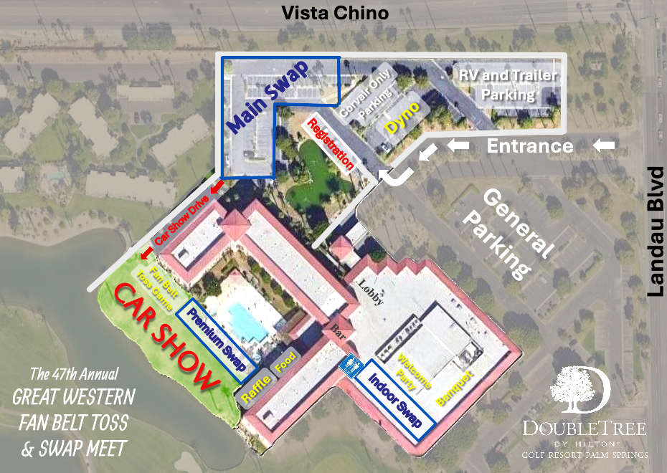
Food
Valve Cover Races
Overflow Car Show

- Registration: Sasha
- Over 110 Hotel Rooms booked. Hotel has added 20 additional rooms at a higher rate ($259 a night) – link updated on website – ends Oct 1st
- Key Dates: Prices go up: October 1st. Banquet ticket sales ended: October 10th.
- 108 Registrations received (as of 9/23)
  - 57 Car show entrants – 16 earlies, 25 lates, 15 FCs, 1 UV
  - 130 Banquet, 129 Friday Welcome Party
- Registration bags – Hagerty bags, Summit goodies, Rally Stop, magnets (Scott), stickers (Vegas Mike), envelope with banquet ticket & Friday night & major raffle tickets & dyno ticket & valve cover car ticket, car show window card, schedule, map, t-shirt …
- For Day of Registration: Registration bags, money box and change, blank registration forms, donation container, printed map + schedule + contact phone # taped to table, table and easy-up
- Vendors: Val Doppenberg
- Registered
  - Main: 34 spaces (max: 40)
  - Premium: 9 spaces (max: 12)
  - Indoor: 8 tables (max: 15)
- Security – Parts Mike & Greg Atwood
- Vendor space layout – assigned spots
- Vendor’s with inventions – want a timeslot to present/Q&A? Need to create Schedule for these.
- Friday Dyno: Scott/Kregg (Inland Empire)
- Friday Only: 10 AM – 5:00 PM
- Whiteboard for results
- Announcements/speaker system
- Awards at 5 PM Friday – Turbo, 2 Carb, 4 Carb, Non-Corvair.
- Friday Cruise: Brad (Vintage Corsa)
- Mapped out. GPS total drive time: 42 minutes.
- 63 signed up
- Print route
- Start lining up at 5 PM
- Contact city for police escort/inform of cruise - no
- Photographer – Dean Mejia confirmed
- Hand out flyers Thurs/Fri for Saturday’s car show – Scott will print
- Friday Welcome Party: Sasha & Nettie (SCC)
- Catered by hotel – buffet style – food: 2 pork sliders per person + chips (150) + Hummus/Taco plates (30)
- Trivia or networking game? – Corvair Bingo – thank you Vince!
- Ticket & check in list
- Banners/decorations – Taking it back theme – fan belt toss memorabilia
- TV to display old photos and articles on FBT
- Car Show: Byron Linford (Utah)
- Staging layout/setup/park cars
- Car Show Awards – Byron will make all (Matt will provide his award).
  - People’s Choice. Ladies’ Choice. Matt’s Choice. Byron’s Special Awards.
  - Judge panel for main categories – 2 groups of 3 judges (1 per club) – 8 categories each + all vote for best of show (only 1 award per car)
  - 17 Categories (Best for each):
    - Early Model – Convertible, Coupe, Sedan, Wagon
Late Model – Convertible, Coupe, Sedan
Forward Control – FC Van, Rampside
Ultravan
Specialty – Survivor, Best Engineering, Best Paint, Best Patina, Best Interior, Best Water-Cooled, Best Engine, Best of Show
    - Guidelines for judging categories – Byron’s to-do
    - Byron to create order of priority of awards
    - Byron to schedule Friday judges meeting
    - Judges:
      - Vince (Central)
      - Carl (SCC)
      - Kevin Britt (Vegas)
      - Bill (Corsa West)
      - Jim (Central)
      - Doug (Utah)
- PA System – Inland Empire
- Banners – Byron will make for event and sponsors
- Supplies: Flags and string, voting ballots, ballot box, dash plaques, signage
- Max 80 - overflow in grass area by Welcome Party
- Photographer?
- Games: Dave (Cactus Club) and Nettie (SCC)
- Fan Belt Toss – SCC – Nettie (SCC)
  - setup/sign-ups/run game
  - awards - Chuck will make 1st place team + $50 per person for 1st place
- Valve Cover Races – Chuck (SCC) and Dave (Cactus Club)
  - 14 registered
  - Youngest Racer, Oldest Racer, Best Crash, and Best Decorated Valve Cover – Cactus Club
  - 1st, 2nd, and 3rd – Chuck Rust
  - Entrance proceeds to be given to Cactus Club
- Large Jenga & cornhole (big and small) – Nettie
- Car parts Scavenger Hunt – Val
- Other: Car Puzzle/Checkers/Mancala - Sasha
- Craft table/coloring pages/hot wheels tracks/kids activities – Cactus Club (swap area) & Sasha (indoor table)
- Field Raffle: Mike Evans (San Diego)
- Simplify Drawings: 2-3 on Friday, 2-3 on Saturday, and 1 for non-claimed on Sunday
- Container for field raffle & individual ones for each Raffle Basket
- Raffle items – doing well
- Gift Basket Club Competition: Sasha and Mike Evans (San Diego)
- Proceeds will be split 50% to the winning club determined by ticket count, 50% to GWFBT
- Clubs signed up:
  - Inland Empire (Scott)
  - Vintage Corsa (Dan)
  - Cactus Club (Dave)
  - Vegas Vairs (Mike)
  - SCC (Nettie)
  - San Diego Corvair (Jim)
  - Corsa West (Margarita)
- History/Educational material: Bill & Margarita (Corsa West)
- Library in lounge area
- Display on Corvair history
- Display Fan belt toss memorabilia for Friday night
- Other activities: Val Doppenberg
- Tune-up workshop – Friday – Val & Greg Petersen
- Exhibit: Full Restoration Project car – Greg Petersen presents Tom’s car
- Exhibit: Wayne 100 corvair powered boat?
- Exhibit: Matt’s Morrvair
- Presentation & Q&A – Billet Heads – Paolo Galli
- Other Vendors present?
- Photobooth – simple setup w/ tripod, frame, hats/signs
- Nader cutout – Mike Vintage Corsa (confirmed)
- Music 2x: Car show & swap Meet – Nettie has tunes. Paul M. has tunes.
- Banquet: Multi-Club
- Speaker scheduled to appear: Matt of Matt’s Off-Road Recovery
  - Follow up for Byron - Matt’s “Corvair” writeup
- Banquet ticket sale closed: October 10th
- Banquet tickets standby for cancellations?
- Catering – Italian Buffet
- PA system – Kregg sets up (Inland Empire)
- Centerpieces
- Awards:
  - Hard Luck Award – Chuck will make + $20 Clarks gift card
  - Longest distance in a Corvair
  - Eldest Attendee Award
  - Newest Corvair Owner (Inland Empire)
- Traditional raffle: $100 per club (Nettie presents)
- Raffle prizes: 4 buckets (Mike Evans)
  - Rebuilt Transmission
  - 2 nights Resort stay
  - Neon Corvair sign
  - TV
  - Combine all buckets for a chance at Clark’s $500 GC
- Matt might gift some Matt’s Off-road Gear
- Video recording of speech? Photographer?
- Framed corvair art/banners/etc to decorate banquet room
- Sunday Event: Sasha & Val
- Lunch at Panera Bread @12:00 PM
- Air museum @1:30pm - $20 a person for groups of 20+
- Corvairs allowed to park in the roundabout
- 30 interested registrations (about 50 people)
- Graphics & Merch: Scott (Inland)
- GWFBT T-shirts, glasses, cozies, tote bags for sale at Flatsix booth
- Advertising: Sasha
- Social media/forum posts – more engagement
- Corsa/Communique – event posted
- Advertise in Palm Springs
  - VisitPalmSprings.com & VisitGreaterPalmSprings.com
  - Hung Flyers @ local auto parts and businesses across the street.
  - Flyers to hand out at Thursday night in Palm Springs. Friday Cruise.
- Email list – sent twice.
- Facebook event – created. Share the invite!
- Keep sharing the event! And register!
- Banners for registration table
- Finances: Ronda (Vintage Corsa)

Post Show: Sasha & Scott (Inland Empire)
- Winners posted
- Post show survey
- Post show write-up – thank you and results
- Interview best of show
- Update Website and Social Media Accounts

Hotel Meeting Notes from 9/30:
- Friday Welcome Party – 6:30 cash bar/seating open 7:30 PM food 9:30 end
  - Will ask about pushing Happy Hour specials to our bar
- Banquet – 6 PM social hour/cash bar open 6:30 banquet room opens 7 PM dinner
  - plated – pot roast or chicken or vegan/vegetarian option
  - Italian Buffet
  - 10 people per table
- Car Show
  - Ramp for cars – needs to be widened by sandbags maybe
  - Sprinklers off for Thursday to Sunday
  - Power for grass area – yes - extension cord needed
  - Saturday BBQ time (11 am – 1pm or later), menu: chicken sandwiches and burgers, price: about $15
  - Setup on Thursday: Grass/parking lot/lounge area (not responsible for items)
    - No canopy’s or standing tables outside overnight due to winds
  - Seating/eating area outside - @ pool and patio
  - Overnight Parking on grass allowed from Thursday evening – there’s no lights in grass area
  - Restrictions for grass area – no glass. Personal coolers allowed. No fires.
  - Gate to grass area to be closed but not locked overnight
- General
  - Tables indoor – 15+ provided – 6ft
  - Copy of bar/restaurant menu - received
  - Check in/ out times for hotel: Check in at 4 PM. Checkout 12 PM.
  - Bar/food hours: 11 AM to 11 PM. Breakfast at restaurant 7 AM – 11 AM.
  - Pool hours: 7 AM to 10 PM
  - Hotel Security – yes. 1 guy that makes his rounds.
  - Reviewed our Event map
  - Garbage Cans for outside – hotel will provide
  - Tables to display corvair lit
  - Restrictions for decorations – can hang on walls using removable putty
  - Coolers are allowed – no glass bottles/etc.
  - Can hang banners from our balconies – Clubs bring your banners!!
  - ATM onsite – by Bar/elevator
- V8 Club Meeting options – No charge for holding it in restaurant (empty after 11 am) – can order off the regular lunch menu (pre-order is optional)

