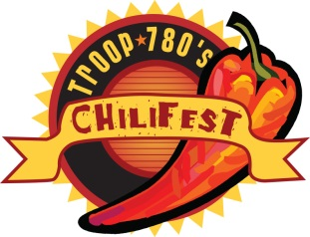
Boy Scout Troop 780
Car & Motorcycle Show
Entry Form 2017

Register by September 1, 2017
- Registration fee is $20 per vehicle, $25 for the main hall at Douglas County Fairgrounds Event Center
- Registration fee includes entry into the ChiliFest for 2 people to sample/judge all chili entries (a $16 value)!
- All cars and motorcycles of all makes and years welcome
- Individuals and Car/Motorcycle Clubs are encouraged to enter
- Trophies provided by Troop 780 ChiliFest
- Dash plaques available on a first come basis while supplies last
- Arrive between 3:00 and 3:30 pm. Main Hall indoor space is limited so reserve your spot!
- Please keep cars/motorcycle on display until at least 6:45pm (weather permitting). Cars/motorcycles inside the event center must stay on display until the event is closed (8 pm).
- Voting will be done by the attending public (by popularity) and awards will be given out around 7:30pm.
Please PRINT all information neatly.
Vehicle Owner Name: _______________________________________________ # of Vehicles Entering: _____________
Address: ______________________________________City: __________________________State: _________________
Email Address: __________________________________________________Phone#_____________________________
Vehicle 1: ☐ Car ☐ Motorcycle Make/Model/Year ____________________________________
☐ Main Hall Entry ($25) ☐ Outside Entry ($20)
Vehicle 2: ☐ Car ☐ Motorcycle Make/Model/Year ____________________________________
☐ Main Hall Entry ($25) ☐ Outside Entry ($20)
Mail this form with a check payable to:
BSA Troop 780
Attention: ChiliFest Chili Cook-Off
PO Box 562
Castle Rock, CO 80104
Thank you for your participation!

Questions: Please call Chad Church @ 303-434-6439 or email castlerockchilifest@gmail.com

