THE WILD ANIMAL SANCTUARY DAY TOUR
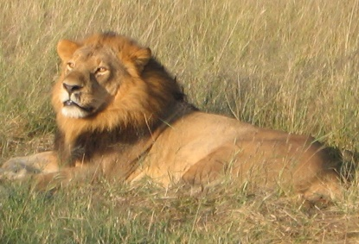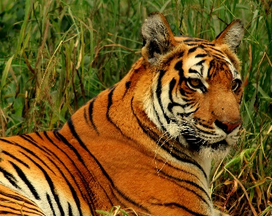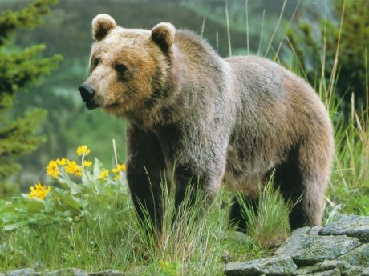
This Photo by Unknown Author is licensed under CC BY-SA
This Photo by Unknown Author is licensed under CC BY-SA
This Photo by Unknown Author is licensed under CC BY-NC-ND
This coming Saturday, June 22nd, the RMC is taking a day trip to The Wild Animal Sanctuary outside of Keenesburg, CO. This is a 10,000 acre sanctuary specializing in rescuing and caring for large predators that had been mistreated. They have tigers, bears, lions, wolves, and over 460 other large predators. There is an overhead walkway to view the animals in large acreage habitats, which is wheelchair accessible.
We will meet at the parking lot at 10:00 a.m. in front of the Welcome Center. After seeing the animals, we will have lunch at the Welcome Center. There are choices of restaurants, or you can bring in your picnic lunch to enjoy at their picnic tables.
Cost: Adults 13-69: $30 Children 3-12: $15, under 3 are free
These costs help to support the animals.
**NO DOGS ARE ALLOWED, EVEN IF THEY ARE SERVICE DOGS**
Directions: These directions begin at hwy 25 & 76. Drive time from this point is approximately 35-40 minutes. Plan your arrival accordingly from your home. From Denver, take 76 northeast and take exit 31 for CO 52 toward Hudson. Turn right onto CO 52 east, (Main St) 4.2 miles to CO RD 53. Turn right and follow it to the signs to the Wildlife Sanctuary Entrance: 2999 Co Rd 53

