1963 Chevy
Corvair Convertible

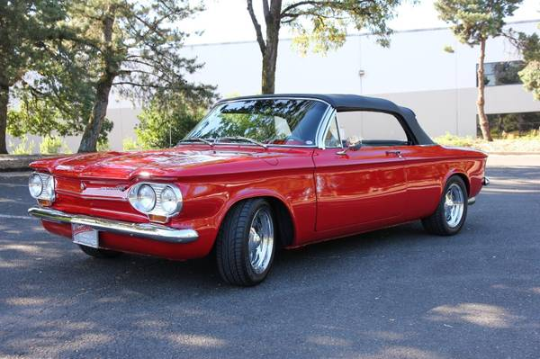
Custom Paint: Victory Red
Custom Upolstery: Jim’s upholstery
Wheels: Colorado Custom
Engine: Built 1965 Corvair, Horizontal
6 Cyl 140 HP
Trans: 4 Speen Manual
Trans Axle: 3.55 gears

Owner: Jean Kughn, Monroe, Oregon

