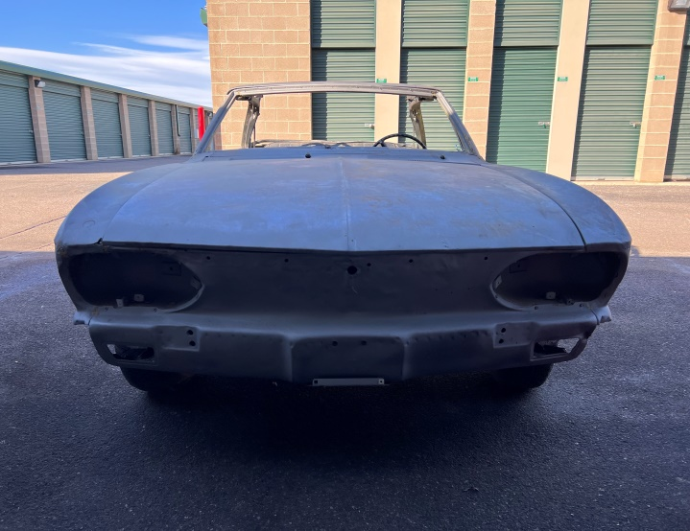 | 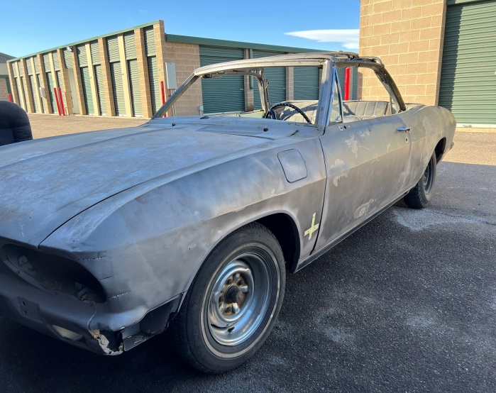
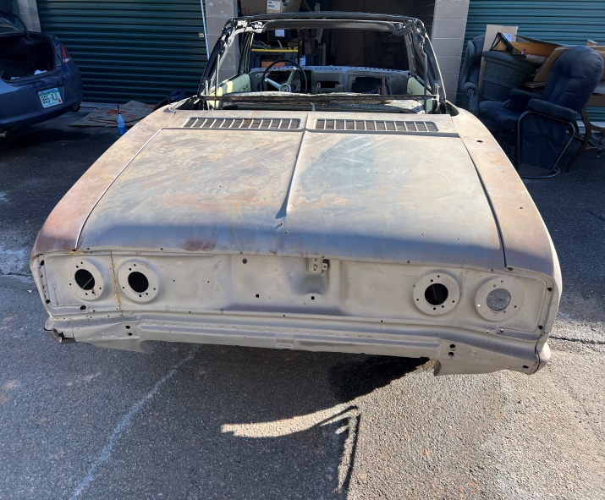 | 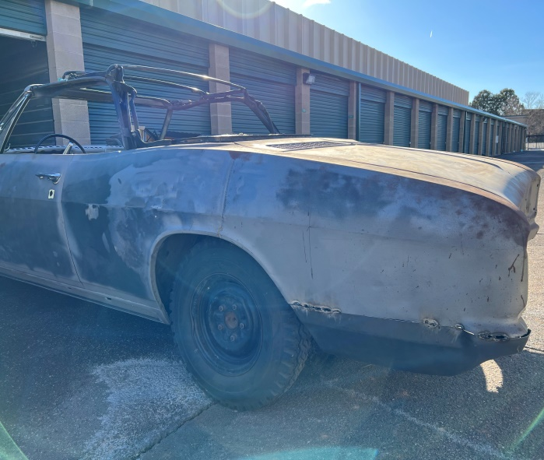
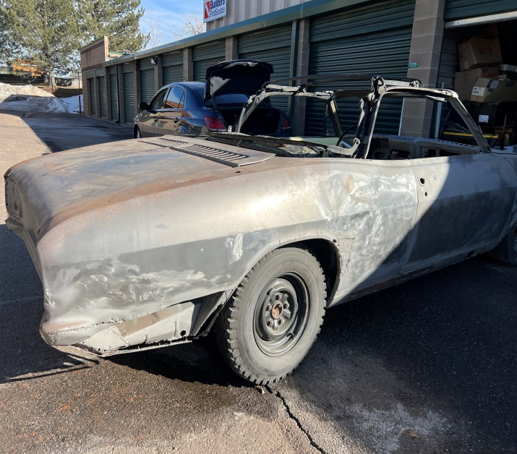 | 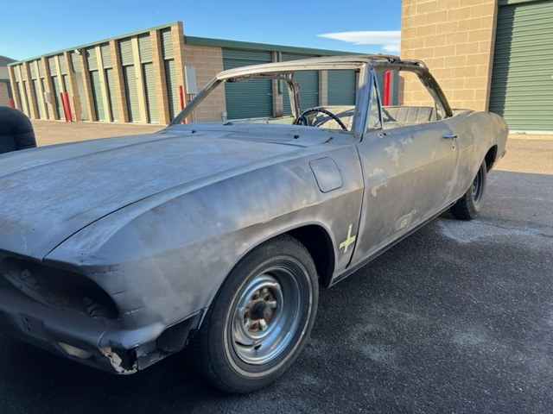

1967 Corvair Monza Convertible for Sale - $1,500
Details:
- Definitely a "Project Car" for someone who has the time and appreciation for this very rare Corvair. There were only 2,109 Convertibles built in 1967.
- I had the car media blasted and I had begun cutting out rusted areas that would be replaced with patch panels.
- I have also removed all the interior and will include all the parts that I have for the car.
- It has the 140 engine with the 4 Carburetor set up. I believe that most of the engine parts are there, but the previous owner pulled the heads and began to disassemble the engine, so I can’t guarantee this.
- The original seats will need to be recovered, but I do have a second set of seats that I will throw in as well.
- My price is $1,500. I am basically selling the car for less that I have in it because I would love to see someone get it back on the road. I wish that I had the time and workshop to work on it, but I have had it for a while and it is time to get it to someone who does.
- I have the title for it, but there is no odometer reading on the title.
- I am selling the car “As Is”.
- Please let me know if you have any questions for me.

Please Contact :
Steve Fernalld
720-505-0976
stevefernalld@comcast.net

