Corvairs and Parts For Sale:
1966 Monza Sports Sedan
110 powerglide (stuck)
Original paint
Ran when parked (1975)
Out of an estate in Wetumpka, AL

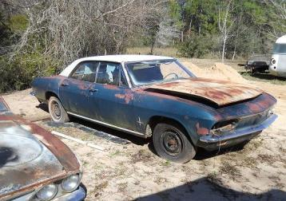
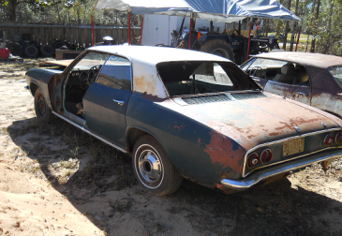

1965 500 Sports Sedan
Two owners
Ran when parked
Only been under water once (Maybe twice)
95hp powerglide
Paperwork in a lump in glove compartment
Will help load
$200 (Price reflects condition)
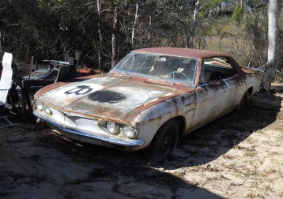
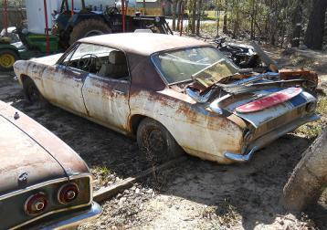

1968 Ultravan #407
Gutted Dragged out of swamp
No drivetrain Basic structure good
Excellent candidate for custom build
Have title with long lost engine number
$1500 OBO
Will help load, you bring trailer
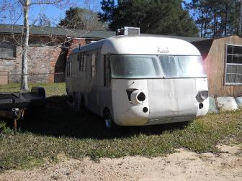
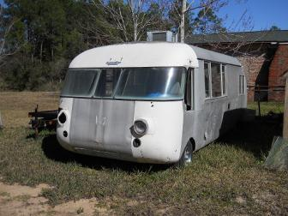
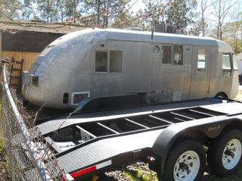
1961 Rampside
Dragged out of field in AL Ran when parked
Only been under water once (maybe twice)
Will help load (If it breaks in two, you own both halves)
Some paperwork might be available
110 hp (?) 4 Speed
$200 (Price reflects condition)

